Jackson Heart Study Protocol

Manual 7

Carotid Ultrasound Assessment: Scanning Procedures

Visit 1

Version 1.0

February 17, 2000

For Copies, Please Contact:

Jackson Heart Study Coordinating Center
Jackson Medical Mall
350 W. Woodrow Wilson Dr.
Jackson, MS 39213

FOREWORD

This manual is one of a series of protocols and manuals of operation for the Jackson Heart Study (JHS). The complexity of the JHS requires that a sizeable number of procedures be described, thus this rather extensive list of materials has been organized into the set of manuals listed below. Manual 1 provides the background, organization, and general objectives of the JHS Study. Manuals 2 and 10 describe the operation of the Cohort and Surveillance Components of the study. Detailed Manuals of Operation for specific procedures, including those of reading centers and central laboratories, make up Manuals 3 through 9 and 11.

JHS Study Protocols and Manuals of Operation

MANUAL | TITLE
1 | General Description and Study Management
2 | Cohort Component Procedures
3 | Family Study
4 | Blood Pressure
5 | Electrocardiography
6 | Echocardiography
7 | Ultrasound Assessment
8 | Pulmonary Function Assessment
9 | Specimen Collection and Processing
10 | Cohort Surveillance
11 | Data Management System

Manual 7. Carotid Ultrasound Assessment: Scanning Procedures

Table of Contents

1.0 INTRODUCTION 1
2.0 SCANNING INSTRUMENTATION 2
3.0 EQUIPMENT MAINTENANCE 3
3.1 Ultrasound Imaging System 3
3.2 Video Cassette Recorder 3
3.3 RMI 414 B Tissue Mimicking Ultrasound Phantom 3
4.0 Ultrasound Equipment Performance Check 4
4.1 Overview of phantom scans 4
4.2 Labeling and shipping phantom scans to URC 4
4.3 Additional Points to Remember 5
5.0 Equipment and Supplies 6
6.0 ARTERIAL SITES AND ANATOMIC STRUCTURES TO BE EXAMINED 7
6.1 Priority for Boundary Visualization 8
6.2 The Carotid Arteries 8
7.0 PARTICIPANT PRELIMINARIES 13
7.1 Participant Orientation to Ultrasound Examination 13
7.2 Participant Apparel 13
7.3 Preparation for Ultrasound Examination 13
7.4 Connection of ECG leads 14
8.0 CAROTID SCANS 15
8.1 Right Carotid Scan 15
8.2 Left Carotid Scan 17
9.0 SONOGRAPHER TRAINING, CERTIFICATION AND MONITORING 18
9.1 Training 18
9.2 Certification 19
9.3 Monitoring 21
9.4 The B-Mode Study Scan Evaluation Form 22
10.0 SUMMARY OF LEAD SONOGRAPHER DUTIES 23
11.0 LABELING AND MAILING TO THE ULTRASOUND READING CENTER 24
11.1 Labeling of Video Cassettes 24
11.2 Log Sheets 24
11.3 Content of Mailing 24
11.4 Frequency of Mailing 24
11.5 Package Labeling 24
11.6 Verification of Mailing Contents 25
12.0 POLICIES / PROCEDURES FOR IDENTIFYING CAROTID ULTRASOUND ALERTS 26

Appendices

Appendix 1 Doppler Signal Identification of the Internal Carotid Artery A-1
Appendix 2 Log Sheet Reference A-3
Appendix 3 Video Cassette Labeling Diagram A-5
Appendix 4 Weekly Shipping Log A-7
Appendix 5 Information Reference Sheet A-9
Appendix 6 URC Contact Information A-11
Appendix 7 Articles of Interest A-13

Manual 7. Carotid Ultrasound Assessment: Scanning Procedures

Figures
Figure 1. Carotid Artery Schematic 7
Figure 2. Ultrasound Image of Common Carotid Artery Interfaces 8
Figure 3. Ultrasound Image of Carotid Landmarks 9
Figure 4. Externally defined interrogation angles 10
Figure 5. Placement of ECG leads. 14
Figure 6. Right Transverse and OIA 15
Figure 7. Left Transverse and OIA 17

.

INTRODUCTION

The procedures and equipment described in this document are based on those developed for use in the Atherosclerosis Risk in Communities (ARIC) study, and are designed to maximize comparability with ARIC measurements previously collected on a subset of the Jackson Heart Study cohort.

SCANNING INSTRUMENTATION

The ultrasound area instrumentation consists of a Hewlett Packard SONOS 4500 ultrasound imaging system, an sVHS Video Cassette Recorder, and an RMI 414B Tissue Mimicking Ultrasound Phantom. A brief description of each piece of equipment follows.

The vascular ultrasound imaging system with a 7.5 mHz transducer is designed for the interrogation of relatively shallow anatomical structures such as the extracranial carotid arterial system. During B-mode imaging, an ECG tracing can be superimposed on the image screen to assist in the selection of images from specific time sequences within the cardiac cycle. In addition to the B-mode image, Doppler signals from the arteries can be obtained, processed and displayed in a frequency versus time format. The Doppler information is used primarily for arterial identification and for evaluation of lumen encroaching lesions for possible ultrasound alerts.

A sVHS video cassette recorder (VCR) is connected to the scanner. The VCR records the ultrasound video information coming from the scanner’s video channel and an audio signal capturing the sonographer’s verbal commentary during the scan.

A modified RMI 414B tissue mimicking ultrasound phantom with water trough attachment is used periodically for performance checks on the scanner. The phantom has arterial mimicking targets of various diameters and depths. These targets can be scanned from both longitudinal and transverse directions, and the images and video information can be evaluated to assess system performance. The images are recorded on 1/2" sVHS video cassettes and sent to the URC.

EQUIPMENT MAINTENANCE

Detailed records of equipment maintenance are to be kept at the field center.

Ultrasound Imaging System

The field center will maintain a regular schedule of preventive maintenance checks every six months. More frequent service visits may be required if any problems occur between scheduled preventative maintenance visits. Service visits may be recommended by the URC if readers or expert reviewers note deterioration in image quality or if regular phantom scans indicate a performance problem. A log of all service visits will be kept at the Field Center, indicating the visit date, reason for the visit, technician performing the service, and any actions taken.

Video Cassette Recorder

The Video Cassette Recorder should be cleaned on a regular schedule as indicated in the operator’s manual. Based on the quality of images received, the URC may recommend additional service for the VCR at any point during the study.

Before scanning is attempted each day, a short series of ultrasound images should be recorded to video cassette and played back to confirm that the VCR settings are appropriate and capable of recording both video and audio signals.

RMI 414 B Tissue Mimicking Ultrasound Phantom

The RMI 414B phantom is checked monthly to be sure all seals are tight and that the tissue mimicking gel inside has not dried out. Proper care and maintenance of the test phantom, along with standard specificiations, are described in the instruction manual accompanying the phantom. The phantoms are stored in an airtight, resealable plastic container. A few drops of water or a wet sponge should be added to this container before sealing to minimize desiccation of the tissue mimicking material.

Ultrasound Equipment Performance Check

Overview of phantom scans

An ongoing quality assurance check of scanning instruments is performed once each month at the field center and immediately after any service visit or replacement of the transducer. The QA check is based on a standardized scan of the RMI Tissue Mimicking Phantom. The scans are recorded on video cassette and sent to the URC for evaluation. In each scan, a 6 mm diameter simulated vessel and a set of filaments located at different depths within the phantom are visualized.

Regular twice a month phantom scans are performed on the second Wednesday of each month. The RMI 414B ultrasound phantom is placed upright on the examination table with the long side of the rectangular case parallel to the longer side of the table. The end of the phantom containing the filaments ranging from 0.5 to 4.0 cm should be positioned closest to the head of the table.

The top surface of the phantom is cleaned with a damp cloth or paper towel to remove residue. The water tray on the top of the phantom is half-filled with tap water to permit efficient coupling of the ultrasound transducer to the tissue equivalent medium. DO NOT USE GEL AS THE COUPLING MEDIUM. Minimal pressure is exerted on the phantom surface with the transducer throughout the scan. Excessive pressure or gel on the phantom surface can cause severe damage to the phantom.

A segment of B-mode phantom images approximately 2 minutes in length is recorded during this check as described below. Selected frames are read at the URC to quantitatively document the ultrasound system imaging characteristics.

With the VCR in record mode, adjust the video gain and other settings for optimal imaging. Throughout the scan, exert only minimal pressure on the phantom surface with the transducer. To obtain the images in this procedure the long dimension of transducer should be parallel to the long dimension of the phantom. The sonographer obtains a cross-sectional (transverse) view of the most superficially (2 cm depth) located simulated vessels and then positions the larger (6 mm diameter) of the three vessels in the vertical center of the screen. Verbally indicate when you have acquired satisfactory images of each structure to assist the reader in identification of video cassette frames for assessment.

The sonographer then moves the transducer toward the head of the table in order to view the set of filaments ranging from 0.5 to 4.0 cm. These are also viewed in cross-section (transverse), making certain the transducer focus setting is in an appropriate position. The filaments are lined up so that they are centered horizontally across the center of the screen. The reflections of the deeper filaments may have gaps in them due to shadowing caused by the filaments superficial to them. Those gaps are used as an aid in lining up the filaments properly. When a satisfactory image is seen, verbally mark this point on the tape for the URC.

This concludes the monthly instrument performance test on the RMI phantom. The water is carefully removed from the phantom, and the phantom is returned to its storage location in the manner described in Section 4.3.

Labeling and shipping phantom scans to URC

Phantom scans may be recorded on the same video cassettes as participant scans. Phantom scans must be identified on the Log Sheet (see Appendix 2) by writing “Phantom Scan” in the space for participant ID. In addition, the gain setting used to obtain optimal images should be recorded in the comment field. A log of phantom scan dates is maintained at the Field Center to ensure these tests are performed per the above schedule.

Additional Points to Remember

While scanning the phantoms, the sonographer is to look for changes in the following:

- shape of simulated vessels (these should appear circular)
- the gain settings required to obtain adequate images, or
- the focal settings required to obtain images.

If the sonographer notices changes in any of these conditions, he/she should contact the service technician authorized to work with this instrument and make a notation of that contact and it’s resolution in the Field Center service log. Following any service call, the chief sonographer is to send a copy of the service report to the URC Coordinator and/or Phantom reader.

If the phantom surface begins to cave in or pucker:

- Call the supplier to arrange service.
- Notify the URC Coordinator immediately.

It is important to vary the location of the transducer within the prescribed areas on the phantom when performing phantom scans in order to extend the life of the phantom.

Equipment and Supplies

In addition to the Hewlett Packard SONOS 4500 ultrasound imaging system and sVHS cassette recorder, the carotid scanning station should include an examination table, a chair with adjustable height control, and an overhead light or room lamp with a dimmer switch to allow the sonographer to control the ambient light level in the room.

Daily supplies include:

- sVHS video cassettes
- Participant ID Labels - Identification labels are applied to the video cassettes
- Aquasonic gel
- Paper wipes
- Foam wedge
- Soft arch apron and clips
- Pillow to be placed underneath participant’s knees

In addition to these daily supplies, a VCR head cleaner should be available for use according to the manufacturer’s recommended maintenance schedule or in response to noticeable image degradation.

ARTERIAL SITES AND ANATOMIC STRUCTURES TO BE EXAMINED

Ultrasonic imaging methods are used to obtain a non-invasive quantitative measure of early atherosclerotic disease. The carotid arteries, the principal suppliers of blood to the brain, are a common location for early disease, primarily within or in close proximity to the bifurcation. These arteries, generally located within a few centimeters of the skin surface, also are well suited to examination with high resolution ultrasonic imaging methods.

The ultrasound examination concentrates around the portion of the carotid artery known as the carotid bifurcation (See Figure 1). The JHS carotid ultrasound examination attempts to obtain images at 3 defined segments (Common, Bifurcation, and Internal) of the right and left carotid arteries. Three circumferential views are at the Common segment (anterior, lateral, and posterior) simultaneously imaging the near and far walls in each view. Three views are also obtained at the Bifurcation (one simultaneously imaging both the near and far walls, and two additional views focusing separately on the near and far walls to accommodate the curvature typical of the bifurcation). A single view is obtained at the Internal segment.

All views of the Bifurcation and Internal segments, and one view of the Common segment are obtained at the optimal interrogation angle (OIA), an internally defined angle that clearly shows the tip of the flow divider (TDF) and origination of the internal and external carotid arteries.

- Carotid Artery Schematic

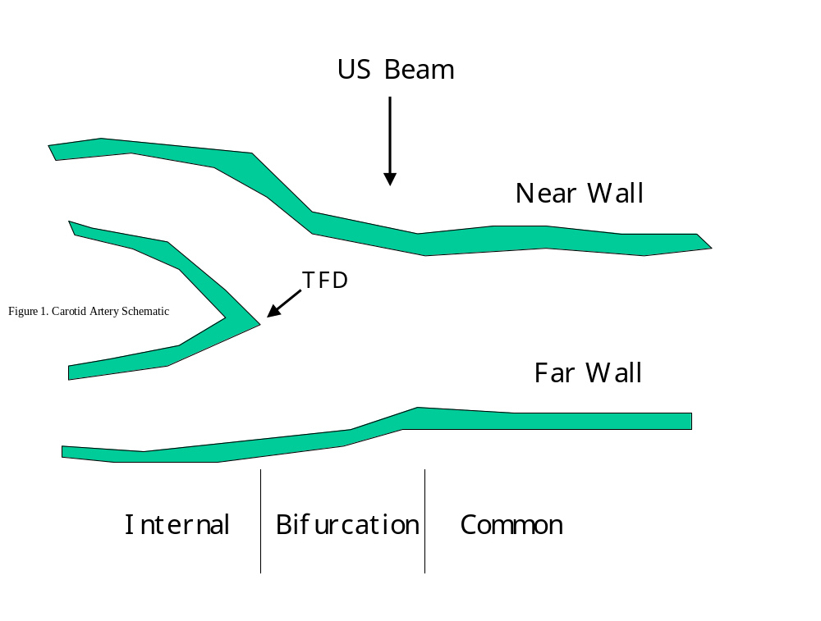

Priority for Boundary Visualization

In many instances, it is difficult to simultaneously obtain high quality longitudinal images of both the near and far wall boundaries of the arterial segment being examined in the same image frame. This condition results primarily from the highly specular nature of the ultrasonic reflections from the blood-intima boundaries and deviations of the arterial geometry from a cylindrical shape. Consequently, priorities must be placed on the order with which arterial wall boundaries should be visualized. Low priority boundaries should be visualized to the greatest extent possible after optimizing visualization of high priority boundaries, but with potentially lesser quality.

- Ultrasound Image of Common Carotid Artery Interfaces

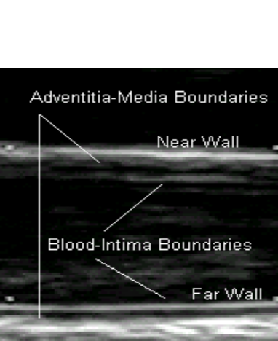

The two boundaries to be visualized first are the adventitia-media boundaries on the near and far walls. These boundaries permit an estimate of the arterial diameter to be measured. The third boundary, the far (deeper) wall blood-intima boundary, is then visualized while maintaining good images of the first two boundaries. This permits a measurement of the far wall intimal-medial thickness. Fourth, if possible without losing this third boundary, the intima-blood boundary on the near (shallower) wall is visualized. An image of the common carotid artery in which all four boundaries are visualized is shown in Figure 2. This sequence of priorities is used when imaging any segment of the carotid arteries that attempts to image the near and far walls simultaneously.

The Carotid Arteries

Anatomical References

The arterial segments defined for ultrasonic examination are referenced to certain anatomical landmarks which are normally identifiable within the carotid system. One is the tip of the flow divider (TDF), the position along the vessel where the internal carotid artery and external carotid artery begin. A second, but less clearly delineated landmark is the location where the common carotid artery begins to widen into the carotid bifurcation. These landmarks are illustrated in Figure 3. In order to image defined segments referenced to these landmarks, longitudinal images are required.

- Ultrasound Image of Carotid Landmarks
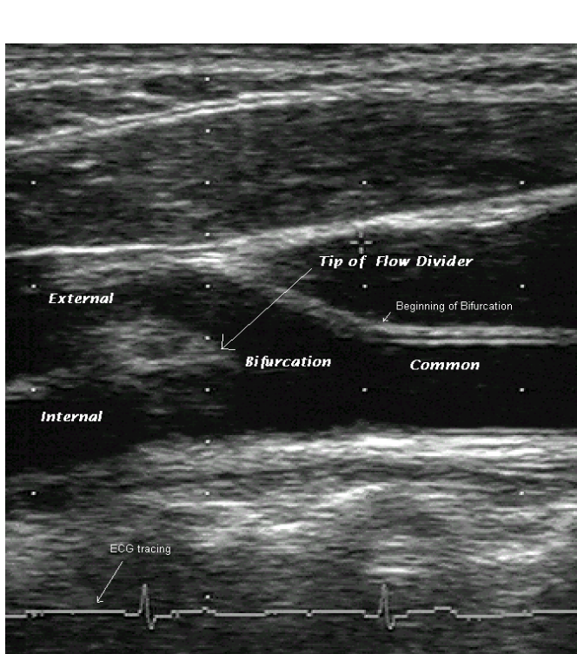

Optimal Interrogation Angle (OIA)

The optimal interrogation angle (OIA) permits clear identification of the anatomical references on the B-mode images and depends upon specific anatomical features of the participant. This dependence of interrogation angle on the individual participant requires that great care be given during the preliminary examination to identify this angle. It depends upon both the ultrasound transducer position and the orientation of the head of the participant.

If the proximal segments of the internal and external carotid arteries lie in a common plane, it should be possible to interrogate the bifurcation from an angle that provides an image characterized by a "Y" appearance. This is illustrated in Figure 3. From this angle, the location of the two anatomical references, the tip of the flow divider and the beginning of the dilation of the bifurcation, can be seen. In some individuals, it may be difficult to sharply define the origin of the bifurcation if a pronounced widening does not occur, but it is most likely to be visible from this angle.

If the proximal segments of the internal and external carotid arteries do not lie in a common plane, it may be impossible for the sonographer to obtain the characteristic "Y" appearance at the bifurcation in a single image. Either one or the other of the branches can be imaged at a given interrogation angle but not both. In many cases, repositioning of the head of the participant (see Section 8.0) may permit the two arteries to more closely approach a common plane. Often careful attention to this position and small participant head angle changes will permit the "Y" to be visualized. A preliminary transverse scan as described in Section 8.1.2 permits the optimal interrogation angle to be closely approximated even in the more difficult anatomical configurations.

Externally defined Interrogation Angles

In addition to the use of the internally defined optimal interrogation angle, it is often convenient to refer to certain externally defined interrogation angles, especially when acquiring circumferential views in the common carotid segment. We define external interrogation angles based on the 360 degrees of a circle centered about the participant’s neck, with the 0 degree point located towards the floor and the 180 degree point oriented towards the ceiling (see Figure 4).

- Externally defined interrogation angles

Participant’s Left Side Participant’s Right Side

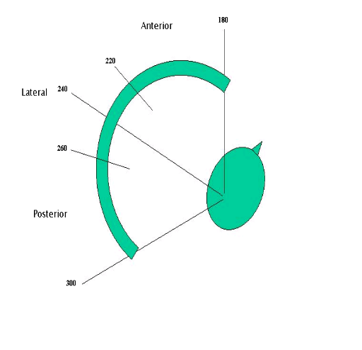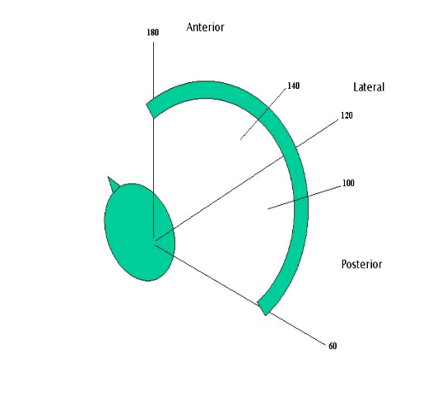
Interrogation angles on the participant’s right side are numbered from 0 – 180 degrees, although angles less than 60 degrees usually cannot be obtained due to restrictions in participant anatomy and interference from the examination table. Interrogation angles on the participant’s left side are numbered from 180 – 360 degrees, although angles greater than 300 degrees usually cannot be obtained due to similar constraints. On the participant’s right side, angles between 100 and 140 degrees are defined as lateral angles, while those from 60 – 100 degrees are defined as posterior angles and those from 140 – 180 degrees are defined as anterior. On the left side, angles from 220 – 260 degrees are defined as lateral, while those from 260 – 300 are defined as posterior and those from 180 – 220 are defined as anterior. On each side, externally defined interrogation angles can be designated either by a specific degree (eg., 210 degrees) or by a region (anterior, lateral and posterior).

The Common Carotid Artery

Initial longitudinal images of the common carotid artery are obtained at the optimal interrogation angle (OIA). The external region (anterior, lateral or posterior) containing the OIA should be identified verbally by the sonographer in degrees. At the OIA, the boundaries of interest are referenced to the origin of the bifurcation where the common carotid begins to widen. The segment located 10 mm proximal to this landmark is the focus of attention. Both the near wall and far wall interfaces are attempted in this view.

If the OIA is a lateral angle, two additional circumferential views are obtained by selecting the most extreme anterior and posterior angles that still permit visualization of at least one and preferably both blood-intima interfaces. If the OIA is a posterior angle, the two additional circumferential views are obtained at the midpoint of the lateral range (120 or 240 degrees, depending on the side) and at the most extreme anterior angle that still permits visualization of at least one, and preferably both blood-intima interfaces. Similarly, if the OIA is an anterior angle, the additional circumferential views are obtained at the midpoint of the lateral range (120 or 240 degrees, depending on the side), and at the most extreme posterior angle that still permits visualization of at least one, and preferably both blood-intima boundaries. After obtaining all 3 views of the common segment, the sonographer should return to the OIA and begin to focus on the bifurcation segment.

The Carotid Bifurcation

The segment of the carotid bifurcation extending 10 mm proximal to the tip of the flow divider is imaged at the optimal angle. In some participants this may extend into the common carotid. The initial longitudinal images are acquired while attempting to visualize the near and far walls simultaneously, taking care to use the priority sequence of boundary visualization described in Section 6.1.

After imaging the far and near walls of the bifurcation segment simultaneously, a series of images are acquired that optimize visualization of the far wall boundaries. At this time, the ultrasound transducer is tilted along the arterial axis in such a manner that the far wall of the bifurcation becomes horizontal in the center of the display screen, while maintaining the OIA. Small changes in transducer angle and instrument settings are made to optimize the blood-intima and media-adventitia interfaces on the far wall. The quality of the near wall echoes will deteriorate while visualization of the far wall interfaces is optimized.

Then, this process is repeated now optimizing visualization of the near wall interfaces. Again, the transducer is rotated along the axis of the artery so that the near wall of the bifurcation is oriented horizontally in the center of the display screen while maintaining the OIA. Small changes in transducer angle and instrument settings are made to optimize the adventitia-media and intima-blood interfaces on the near wall. The quality of the far wall echoes will deteriorate while visualization of the near wall interfaces is optimized.

The Internal Carotid Artery

The segment of the internal carotid artery far wall extending 10 mm distal from the tip of the flow divider is now imaged at the optimal angle. It is important to carefully distinguish between the internal and external carotid arteries using two criteria: (1) normally the internal has a significantly larger diameter than the external; (2) the blood flow velocity pattern in the two vessels as determined with Doppler ultrasound is distinctly different. (See Appendix I for detailed information on use of the Doppler to distinguish between the internal and the external arteries). Used together, these two considerations permit the internal carotid artery to be identified with a high degree of confidence.

During the preliminary scanning procedure it is necessary to distinguish clearly between internal and external carotid arteries. Although tributaries originating from the external carotid artery may occasionally be viewed with B-mode ultrasound to help in this differentiation, in most cases Doppler ultrasound is more efficient and specific for this separation. Briefly, the method and criteria for this identification are as follows:

A B-mode image is obtained of the carotid bifurcation where the common carotid artery divides. In some instances the best anatomical angle will show the flow divider as well as the proximal internal and external carotid arteries. In the remaining cases the flow divider and only one vessel can be seen from a single angle. In those instances the other artery can be visualized by gently rocking the ultrasound probe back and forth in angle or position or both. Doppler is used to differentiate internal and external carotid arteries in these instances. To obtain a Doppler sample of each artery, the Doppler sample volume (0.09mm) is placed into the branch farthest from skin surface. The sonographer observes the tracing on the TV monitor and listens to the Doppler signal. If the ultrasound probe is in the internal carotid artery, the flow pattern will be that of a low-resistance bed. This signal has a rapid upstroke and a quasi-steady flow through systole and diastole. The flow continues throughout the cardiac cycle and begins to increase again at the next systole.

If the Doppler signal does not correspond to the expected pattern, the cursor is placed within the other branch. The external carotid artery is usually nearer the skin surface when viewed from an anterior angle and is a high-resistance vessel. The characteristics of the Doppler signal in this vessel are a forward flow with a sharp upstroke and sometimes a reversal of the flow at diastole (multiphasic).

Abnormal flow is demonstrated by turbulence within the lumen and disruption of normal flow. This is identified in the Doppler signal by broadening the Doppler spectrum. Severe narrowing of the artery lumen is identified by an increase in the expected peak systolic frequency. Complete occlusions with an absence of Doppler signal should be very rare in the JHS cohort.

Because of the more varied positioning and geometry of the internal carotid, the sequence of priorities to be used when imaging this segment is modified from that used in the common and bifurcation. The two far wall boundaries should receive highest priority, the near wall adventitia-media interface next priority and finally the near wall intima-blood boundary.

PARTICIPANT PRELIMINARIES

The participant will have been asked to refrain from smoking, vigorous exercise, and drinking coffee, tea and soft drinks containing caffeine during the night preceding and the day of the ultrasound examination, since these may alter heart rate and/or blood pressure.

Participant Orientation to Ultrasound Examination

The participant is positioned on the examination table in a supine position. The sonographer describes in general terms the examination to be done. A suggested statement follows:

"Ultrasound is a painless and low-risk method to examine arteries using sound waves which you cannot hear but which are able to image arteries under your skin. Before the ultrasound exam begins, a thin gel will be applied to the skin, and an instrument will be placed on it. This procedure will be used to look at the arteries on both sides of your neck. During the examination, you will hear the noise and feel the vibrations of a small motor that is located within the instrument. Occasionally you will also hear the amplified sound of blood flowing through your arteries. The equipment will also record my voice as I name the parts of the arteries I scan. The complete ultrasound examination should be completed within forty-five minutes. Talking or swallowing can cause the arteries in your neck to move out of focus and can prolong the exam. Please try to avoid talking or swallowing as much as possible, especially for a period of 4-5 seconds whenever I say the word “Acquire”. I will also record your heart beat during the exam by placing 3 ECG leads on your chest.”

During this discussion, the sonographer should remember that the examination to be done is not diagnostic in nature, and that all questions asked by the participant that relate to the presence or absence of arterial disease should be referred to the medical director of the Field Center or to his on-site representative.

Participant Apparel

The ultrasound component of this examination requires easy access to the skin overlying arteries in the neck. Jewelry present on the head and neck, including gold chains, necklaces and earrings, is removed prior to scanning.

Before activating the next phase of the study, take a minute to instruct the participant on the "no conversation" rule. Also, remind the participant to "hold questions" about exam results until after the last portion of the ultrasound station exam is completed, since it is important that all participants be "treated the same way".

Preparation for Ultrasound Examination

The subject should assume a supine position on the examination table with his/her legs resting comfortably on a pillow. The participant's position should allow head rotation to either side. The sonographer is seated at the end of the exam table that is nearer the participant's head. The top of the participant's head is about one to three inches from the end of the exam table, so as to afford easy access to the sonographer of the areas of the neck to be scanned. The soft arch apron is placed on the participant’s chest around the neck with the 180 degree mark over the suprasternal notch and with the 90 and 270 degree marks at shoulder level and parallel to the table.

Connection of ECG leads

Monitor leads or electrodes will be attached to the participant’s chest to allow visualization of the participant’s electrocardiogram (EKG) during the carotid artery scan. Conventional locations for the chest electrodes are illustrated below. The “left leg” (LL) electrode is placed below the left pectoral muscle. The “right arm” (RA) electrode is placed below the right clavicle. The “right leg” (RL) electrode, which acts as a ground, is placed below the right pectoral muscle.

- Placement of ECG leads.

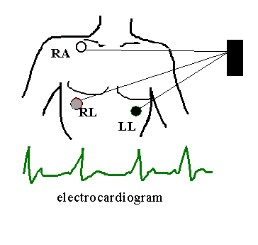

Points to remember:

- the ECG tracing should be positioned at the bottom of the image screen.
- the amplitude should be sufficient to trigger the rate meter.
- artifact - if visualized check to be sure electrodes are not loose or dry. Avoid placing electrodes on bone structures. Limit participant movement during scan.

CAROTID SCANS

Orient the participant's head as follows. The participant is asked to look straight up at the ceiling. A triangular shaped, firm foam rubber wedge shaped in a 45-45-90 degree form is used to position the head in a standard way. The wedge is placed on the examination table, with largest surface of the wedge facing down. It is placed on the examination table next to the side of the neck to be evaluated in such a way that the 90 degree angle is furthest from the midline of the face. This positions a 45 degree angle closest to midline. The wedge is then gently pushed toward the midline of the head until the 45 degree angle edge touches the scalp. The participant is then asked to rotate his head toward the foam rubber wedge until the side of the head just above the ear rests against it. The chin may be raised slightly and the shoulder adjusted slightly for better visualization. The ultrasound equipment is positioned so that the sonographer has access to the participant's neck and all instrument controls.

Right Carotid Scan

Positioning the Participant

The head and neck are positioned for the exam of the right carotid. The foam rubber wedge is placed on participant's left side, and the head is rotated toward the foam rubber as outlined in the introduction to this section.

Preliminary Scan

A careful transverse scan of the common carotid artery is performed with the patient head position and transducer at a lateral interrogation angle. The purpose of this portion of the scan is to learn the arterial geometry of the participant and identify the optimal interrogation angle (OIA). The preliminary scan may also be useful to the reader for identifying the position and severity of suspected lumen encroaching lesions. Using fine transducer angulations to clearly display the blood-intima boundaries within the vessel, the transducer is slowly moved toward the mandible until the widening of the carotid bulb, and finally the internal and external carotid arteries, are visualized. Using the knowledge of the relative orientation of the internal and external carotids from this scan, the optimal angle which should best display the tip of the flow divider may be determined as indicated in Figure 6.

- Right Transverse and OIA

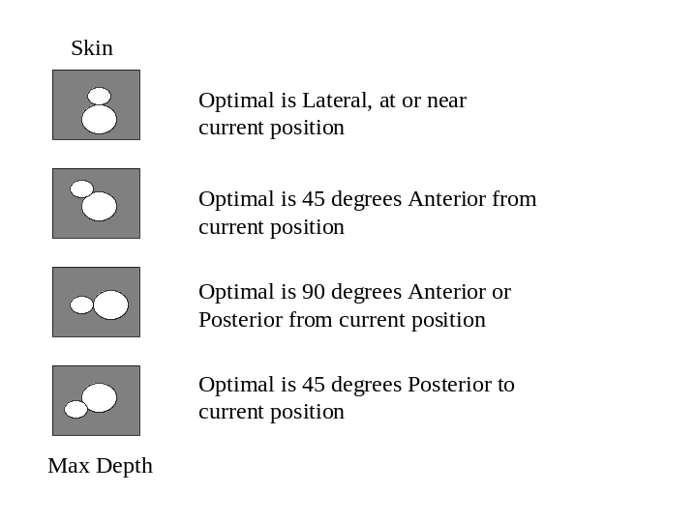

The entire length of each carotid system is now scanned longitudinally at this optimal interrogation angle to provide an overall qualitative impression of the extent and severity of disease and the quality of the image at this interrogation angle. Unusual anatomic features or possible lesions are observed. Oral comments are recorded during the exploratory scan to assist the reader during the reading process, although the sonographer should take care to avoid alarming the participant by using terms like plaque, lesion, or disease, instead referring to structures or areas of interest.

Next, the sonographer determines which artery is the internal carotid artery. This is accomplished by using the Doppler cursor to sample first one branch and then the other. Once the internal carotid artery is identified, the preliminary scan is complete.

Protocol Scan

To begin the protocol scan, the focus of the ultrasound transducer is moved proximally (toward the heart) to view the distal centimeter of the right common carotid artery, immediately below the beginning of the dilation of the bifurcation. Care should be taken to maintain the optimal angle. Once the correct portion of the common carotid is in focus, small manipulations of the transducer are used to orient that section of the artery horizontally in the display window. Additional manipulations of the transducer and instrument settings are made to optimize visualization of the adventitia-media and blood-intima interfaces on the near and far walls. Once the sonographer is satisfied that a high quality image has been attained at the optimal angle, he/she should verbally state “Acquire, Right Common Carotid Optimal Angle in xx region”, where xx is the region (anterior, lateral or posterior) that contains the OIA. This image should be held still for a period of at least 5 cardiac cycles (approximately 5 seconds).

This procedure is then repeated for the two additional circumferential views of the common carotid, with the external interrogation angles determined as described in section 6.2.4. When protocol quality images are attained for each view, the sonographer should verbally state “Acquire, Right Common Carotid Anterior View”, replacing anterior with the regional terms “Lateral” or “Posterior” as appropriate.

After obtaining all three views of the common carotid segment, the sonographer should return to the OIA and focus on the bifurcation segment, attempting to align the mid-axis of the lumen horizontally on the display window. Once visualization of both the near and far wall interfaces has been optimized, the sonographer should state verbally “Acquire, Right Bifurcation Optimal View” and hold that image for at least 5 cardiace cycles. Then the sonographer should manipulate the transducer to bring the far wall of the bifurcation into horizontal alignment and adjust the instrumentation to optimize visualization of the far wall interfaces, taking care to maintain the OIA. Once visualization of the far wall interfaces has been optimized, the sonographer should state “Acquire, Right Bifurcation Far Wall View” and hold the image for at least 5 cardiac cycles. The same procedure is then repeated for the near wall.

After obtaining all three views of the bifurcation segment, the sonographer should focus on the internal segment, extending 1 cm from the tip of the flow divider. In the internal segment, the sonographer should bring the far wall into horizontal alignment, and optimize far wall interfaces preferentially over those on the near wall (both adventitia-media and blood-intima). Only after the far wall has been optimized should the sonographer attempt to image near wall interfaces, with preference given to the near wall adventitia-media boundary over the near wall blood-intima boundary. When the best possible image is obtained the sonographer should verbally state "Acquire Right Internal", and hold the image for at least five cardiac cycles.

After the completion of the internal segment, the gel is wiped from the participant's neck, and the head and neck are repositioned for the left side scan.

Left Carotid Scan

The procedures described in sections 8.1.1 – 8.1.3 are repeated for the left side. After completion of the left carotid scan, the sonographer applies labels appropriately and completes the log sheet (See Section 11). The optimal angle may be determined from the lateral transverse view using Figure 7 below.

- Left Transverse and OIA

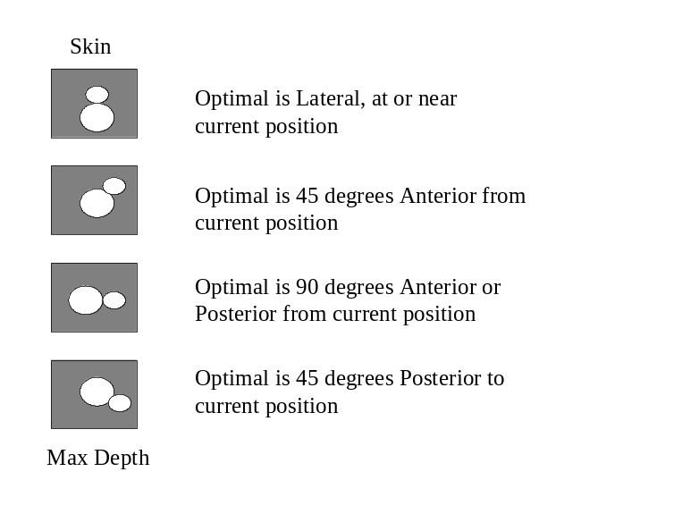

SONOGRAPHER TRAINING, CERTIFICATION AND MONITORING

Training

The sonographer training program includes training sessions held at the field center and/or the URC, followed by practice scans and certification steps at field center.

Stage 1

During the initial weeks, a new sonographer becomes familiar with the scanning equipment, reads the introductory material supplied by the URC, and becomes familiar with this scanning protocol.

Stage 2

The second phase will include several days training by Ultrasound Reading Center staff. Including lectures, demonstrations, and practical laboratory experience on the following topics:

- Overview of the Study.
- Role of the URC.
- Ultrasonic Physics, including basic concepts, properties of ultrasonic waves, reflection at boundaries and scattering from small objects, and the Doppler effect.
- Overview of atherosclerosis and a detailed discussion of the normal artery wall.
- Pathology of Atherosclerosis.
- Principles of Ultrasonic Instrumentation, including pulse-echo imaging systems, pulsed Doppler systems, and spectral analysis.
- Basic operation of the scanning instrumentation
- Instrument Performance Monitoring.
- Principles of Ultrasound Arterial Scanning.

The remaining training time at the field center will be spent practicing scanning technique by implementing the study protocol on volunteers. The field center coordinator and experienced sonographers, if available, need to help the novice sonographers in their recruitment and provide scheduled time for at least one volunteer practice scan per day. The volunteers should be of approximately the same age as the study cohort participants whenever possible. Volunteers scanned for practice cannot be scanned again for certification purposes. The chief sonographer and/or trainer/reviewer at the URC determines when the new sonographer has attained sufficient skills to reliably produce protocol quality scans and begin the certification process. This portion of training is done under the direct supervision of the lead sonographer and/or trainer/reviewer at the URC, who guide, evaluate, offer suggestions for improvements and answer questions as they arise. During this period of active practice, the trainer/reviewer at the URC should be in contact with novice sonographers at the Field Center at least once per week.

Stage 3

When the lead sonographer and/or trainer/reviewer at the URC determines the new sonographer is ready to begin the certification process, the new sonographer scans volunteers with minimum supervision. Certification volunteers must be volunteers the novice sonographer has never scanned before. The novice sonographer must demonstrate his\her skill and understanding of the protocol while scanning a volunteer without prior knowledge of the participant's anatomy. The new sonographer should review these scans to evaluate compliance with the standards of quality of interfaces, artery placement, zoom box alignment, interrogation angles, and overall quality of scanning before shipping tapes to the URC for review. These scans will be evaluated at the URC for effective adherence to protocol, and feedback on overall scan quality and suggested areas of improvement will be provided to the new sonographer in a timely fashion. A minimum of ten scans conforming to the study standards are required before the sonographer will be certified to scan participants in this study.

The sonographer reviewer/trainer at the URC may suspend the certification review process at any point if the novice sonographer fails to demonstrate an ability to consistently implement the study protocol, or if the regular submission of scans for review is interrupted for an extended period of time. If the review process is suspended, the sonographer reviewer/trainer at the URC will promptly inform both the novice sonographer and field center lead sonographer, and recommend additional practice or remedial training. Any scans on certification volunteers that have been approved as conforming to study standards prior to a suspension of the review process will typically be excluded from the set of ten acceptable scans required for certification. Exceptions may be made at the discretion of the URC director.

Certification

Certification of New Sonographers

When a novice sonographer has successfully met all training requirements, as outlined in Section 9.1, written notification is sent to him/her and to the study coordinator at the field center, informing the novice sonographer of his/her new status as a certified sonographer.

Retention of Certification by Experienced Sonographers

A sonographer retains certification to scan based upon the demonstrated ability, while following the JHS scanning protocol, to visualize arterial walls in a fashion consistent with that of other certified sonographers participating in the study. Study data will be evaluated on a regular basis to examine visualization rates and arterial dimensions contributed by each sonographer to assist in the identification of individuals performing differently than their peers. In addition, at least one scan performed by each certified sonographer per month will be reviewed at the URC for compliance with the study protocol. So long as a sonographer maintains visualization and arterial dimensions consistent with the process average of their peers and the average of monthly review scans meet protocol standards, he/she retains certification. If, however, sonographers exhibit difficulty in performing in a fashion consistent with their peers or in passing monthly scan reviews, remedial action will be initiated. If these problems remain unresolved, decertification may become necessary as described in Section 9.2.4. Sonographers who submit no scans suitable for monthly review for two consecutive months will be considered to have lapsed certification. Experienced sonographers may be recertified after submitting 5 scans that pass certification review.

Guest Sonographers

During the course of this Study it is expected that, upon occasion, a sonographer will be unavailable to scan participants without being able to give sufficient prior notice to allow for a reschedule of the participant's visit. If no provisions were made for such an eventuality, participant's would be unduly inconvenienced, or may refuse to return to undergo an ultrasound evaluation. In such a case, in order to prevent a loss of valuable data, the services of a guest sonographer may be used. A guest sonographer is one who is well-versed in the applied principles of carotid ultrasound, and who is familiar with the JHS ultrasound scanning protocol and study equipment. The names and qualifications of guest sonographers are to be registered with the URC, where they will be assigned ID numbers.

Prior to substituting for a certified sonographer for this Study, the guest sonographer is to read the protocol, and review it with the lead sonographer or, in her absence, another JHS certified sonographer. Tapes containing scans recorded by the guest sonographer are to be clearly marked to that effect. Likewise, a notation is to be made on the log sheet.

Upon receipt of these tapes at the URC, these tapes will not be logged in with the tapes produced by certified sonographers. They will first be reviewed by the sonographer reviewer/trainer at the URC . If the scans are found to conform to protocol, they will be logged in and treated from then on in the standard fashion. If, however, the scans are found not to conform to protocol, the scans will not be logged in and will not be read. The field center coordinator, chief sonographer and guest sonographer will be informed of the areas where the scan did not conform to the protocol.

Due to the additional effort required to process these scans, no guest sonographer may scan for more than five days or fifteen scans within a two month period without first obtaining special permission from the Executive Committee of this Study and the Carotid Ultrasound Center Director. Should the field center require additional sonographer support for an extended period, guest sonographers must undergo additional training as specified by the URC in order to become certified for this study. The guest sonographer must submit scans for review for certification and become certified when scanning longer than a five days or fifteen scans within a two month period. At least five scans must pass review before certification can be attained.

Loss of Certification

When a sonographer's boundary visualization rate or measured arterial dimensions depart substantially from those of their or if the average monthly scans reviewed do not meet protocol standards, both the sonographer and the study coordinator will be notified of the specific nature and extent of the problem and a plan for remedial action will be developed in conjunction with the URC. Remedial action may require refresher training at the URC or Field Center.

Scanning Process Control

Timely feedback is critical to the success of this procedure. Therefore, on a routine basis, based on frequency of scanning and sonographer consistency, sonographers will be given detailed reports of their performance, and be notified of the extent to which they conform to the quality and quantity of data gathering exhibited by the Study sonographers as a group. Below are indicated the steps to be followed based on each sonographer's conformance to these standards.

Conforming

- The sonographer and study coordinator will receive written notification of her scanning performance.
- The sonographer will continue to scan.
- The URC will continue to monitor levels of visualization.

Non-conforming - slight

- The sonographer and study coordinator will receive written notification of her scanning performance.
- The sonographer will review the scanning protocol.
- Another sonographer will observe the sonographer perform that part of the scan which was found not to conform to standards and make recommendations for improvement.
- The sonographer will discuss with the reviewer/trainer at the URC ways to improve protocol adherence.
- The sonographer will report back to the URC on the steps taken to effect the improvement.
- The sonographer will continue to scan.
- The URC will continue to monitor levels of visualization.

Non-conforming - moderate

- The sonographer and study coordinator will receive written notification of the sonographer's scanning performance.
- The sonographer will review the scanning protocol.
- The sonographer will review training materials on the principles of physics and anatomy.
- The URC trainer/reviewer will identify patterns which might reveal the reason for failing to conform to the standard, document areas in need of improvement, and communicate her findings to the sonographer.
- Another sonographer will observe the sonographer perform that part of the scan which was found not to conform to standards and make recommendations for improvements.
- The sonographer will practice that part of the scan on volunteers.
- The sonographer will report back to URC on steps taken to effect improvement.
- The sonographer will continue to scan.
- The URC will continue to monitor levels of visualization.

Non-conforming - severe

- The sonographer and study coordinator will receive written notification of the sonographer's scanning performance.
- The sonographer will stop scanning cohort participants immediately.
- The sonographer will review training materials on the principles of physics and anatomy.
- The sonographer will review the scan protocol.
- The URC trainer/reviewer will identify patterns which might reveal the reason for failing to conform to the standard, document areas in need of improvement, and communicate her findings to the sonographer and the study coordinator.
- The URC and Field Center staff will jointly develop a remedial plan, including detailed steps required for recertification.
- When the URC determines that improvement has been demonstrated, with visualization at or above the study average for all sites, the sonographer will be recertified and may resume scanning study participants.
- The URC will continue to monitor levels of visualization.

Monitoring

Sonographer performance is monitored throughout the Jackson Heart Study at both the Field Center and the URC.

Monitoring at Field Center

Each sonographer should review at least one scan every month. During the initial phase of the study and at infrequent intervals thereafter, the lead sonographer may elect to have all sonographers review the same study to help standardize reviewing technique. Once sonographers are familiar with the review process, the lead sonographer should typically assign each sonographer a scan for review that was performed by one of their peers. Reviewing scans performed by another sonographer encourages sharing and standardization of techniques for acquiring and optimizing protocol images, and helps minimize between sonographer differences in protocol interpretation and implementation. The B-mode images are evaluated for overall image quality, the presence and clarity of the arterial wall boundaries, and the presence of anatomical landmarks and a cursor indicating the location of an anatomical landmark and the vessel lumen. Copies of all reviews are sent to the URC on a monthly basis and a review log should be maintained at the Field Center. The Field Center is encouraged to hold monthly sonographer meetings where equipment issues, protocol interpretation, and review results can be discussed.

Monitoring at the Ultrasound Reading Center

Sonographer performance is monitored at the URC using a number of quality assurance procedures. The quality assurance procedures include but are not limited to: (1) comparing results of repeat studies ; (2) periodic reports containing statistics of boundary visualization by individual sonographer and study wide; (3) visual review of randomly selected participant scans; (4) on-site monitoring of sonographer performance by designated URC personnel. Reports are generated and distributed by the URC.

In addition, the URC can review the same participant studies reviewed by sonographers at the field center. The sonographer evaluation form is completed at the URC, and the results are compared to the sonographer's form. Any significant differences between evaluations, or any significant problems are discussed with affected sonographers to resolve the differences. Results of these sonographer evaluations are used to help maintain high standards for participant studies and are part of an ongoing sonographer recertification process.

The URC readers read the ultrasound images from all the data collection procedures and the quality assurance images. Image interpretation results from study images and quality assurance images from the same site and angle are compared for use in sonographer quality assurance procedures. The purpose of this evaluation procedure is to determine the consistency and reproducibility of scanning and of interpreting ultrasound images. The results of these evaluations are reported periodically to the JHS Coordinating Center and the field centers.

The B-Mode Study Scan Evaluation Form

The current version of the B-mode study scan evaluation form is on file at the URC in Winston-Salem, NC. This form provides a forum for a detailed accounting of the conformance to scanning protocol as described in this document.

SUMMARY OF LEAD SONOGRAPHER DUTIES

It may prove useful to designate a single experienced sonographer at the Field Center as a Lead Sonographer, with minimal time (10% FTE) set aside for interacting with the URC staff and maintaining the quality of the ultrasound data at the field center. A summary of duties that may be assigned to a Lead Sonographer is listed below.

- Assist the URC in training new sonographers as described in Section 9.l.3, Stage 3.

- Responsible for reviewing sonographer scanning performance as described in Section 9.3.1.

- Responsible for reviewing the quality assurance data prepared by the URC for the field center, and for each sonographer at that field center. Current values and trends are reviewed, and if problems arise, the lead sonographer and the URC will work together with the sonographer to implement solutions.

- Responsible for reporting ultrasound area equipment problems to the URC.

- Responsible for scheduling preventive maintenance visits and other service calls as needed.

- Responsible for communication with the URC.

- Responsible for sonographer recertification as outlined in Section 9.

LABELING AND MAILING TO THE ULTRASOUND READING CENTER

Labeling of Video Cassettes

Sequentially numbered video cassette labels are provided by the URC. The numbered label is placed along the long axis of the cassette, so it is visible when the cassette is placed in the storage case. In addition, a second label is placed on the face (broad side) of the video cassette, and the participant IDs for all scans recorded on the cassette are written on this label. Typically, 2-3 scans may be recorded to a single video cassette. A diagram illustrating label placement is presented in Appendix 3.

Log Sheets

During the week, the Field Center maintains a log sheet listing the participant ID’s for all scans completed, and the number of the tape to which each scan is recorded. There are also fields to record the location of the OIA for the right and left carotids, a flag to indicate that the sonographer considered the participant a possible ultrasound alert and conducted a thorough Doppler investigation of clinically suspect lesions, and space to record sonographer comments about the scan or equipment performance. This log sheet is included in the weekly shipment of tapes to the URC as described in Section 11.2 below, and a copy is kept at the Field Center. A sample log sheet is presented in Appendix 2.

Content of Mailing

Each weekly mailing from the field centers to the URC contains:

a. Video cassettes for the participant ultrasound studies completed the previous week.
b. A copy of the week's log sheet. (See Appendix 2)
c. A copy of the Shipping Log sheet for the week.
d. A video cassette containing phantom scan(s), if appropriate.

Frequency of Mailing

The video cassettes and lists described in Section 11.1 are mailed each week no later than Tuesday afternoon to the URC. The URC expects to receive these cassettes no later than Wednesday afternoon, and will initiate a trace if delivery is delayed.

Package Labeling

The address label from each field center has the following information:

a. Field center personnel sending the package.
b. Field center return address.
c. The shipping number from the Shipping Log sheet.
d. Address label to the URC:

Ultrasound Reading Center
4310 Enterprise Drive, Suite C
Winston-Salem, North Carolina 27106

Mailing is by services guaranteeing package arrival at the URC no later than mid-afternoon on the Wednesday following the mailing.

Verification of Mailing Contents

The contents are verified upon receipt of shipment at URC. If there are any discrepancies, the field center will be notified.

POLICIES / PROCEDURES FOR IDENTIFYING CAROTID ULTRASOUND ALERTS

Recent studies have demonstrated that subjects with high grade Carotid Artery stenosis may benefit
from medical intervention even if they are free of signs or symptoms of cerebrovascular or cardiovascular disease. Experience with community based cohort studies, including ARIC, suggest that the prevalence of high grade Carotid Artery stenosis in these cohorts is relatively low. The research methods described in this protocol for the measurement of Carotid Artery Intimal-Medial Thickness are not designed to assess Carotid Artery stenosis in any clinically relevant manner. Moreover, identification and evaluation of individuals with high grade Carotid Artery Stenosis typically requires imaging modalities (e.g., color flow doppler) or interrogation angles that are not included as routine components of this ultrasound protocol. Therefore, identification and evaluation of participants with high grade Carotid Artery stenosis is primarily the responsibility of sonographers and the Jackson Heart Study Field Center staff.

Carotid ultrasound readers at the URC will serve as a backup or failsafe for the detection of participants with lumen narrowing that may have been overlooked by sonographers during the ultrasound exam. Readers will flag for further evaluation any scan that appears to have a residual lumen of 2mm or less, whether or not the reader is able to obtain a high quality measurement of lumen diameter at that site. The flagged studies will then be reviewed by the Ultrasound Coordinator and Reading Center Director to determine whether the reader’s impression, combined with information from the transverse scan, other longitudinal views of the artery and any recorded doppler signals are consistent with a high grade stenosis. If the possible existence of a high grade stenosis not previously evaluated by the sonographer is confirmed, this information will be communicated directly to the JHS Field Center staff for further evaluation and, if necessary, communication with the participant. Our experience with the ARIC study suggests that less than 5% of all high grade Carotid Artery stenoses will be first identified by readers in this fashion.

To reduce duplication of effort and possible confusion regarding the reporting of possible high grade stenoses, sonographers are instructed to complete a section on the ultrasound log sheet (see Appendix 2) indicating whether or not they performed a supplemental scan to evaluate the possibility of high grade stenosis in each participant. The possibility of high grade stenosis will be evaluated at the URC only for those participants not receiving special evaluation at the time of their carotid scan. Routine results reporting to the data coordinating center will indicate, for each participant, whether (1) no abnormalities were identified by either sonographer or reader, (2) high grade stenosis was suspected and evaluated by the sonographer at the time of the carotid exam, or (3) a possible high grade stenosis not previously evaluated by the sonographer was identified by the reader and reported back to the field center staff for further evaluation.

APPENDICES

Appendix 1 Doppler Signal Identification of the Internal Carotid Artery

It is important to carefully distinguish between the internal and external carotid arteries using two criteria. First, the internal normally has a significantly larger diameter than the external; second, the blood flow velocity pattern in the two vessels as determined with Doppler ultrasound is distinctly different. Used together, these two considerations permit the internal carotid artery to be identified with a high degree of confidence.

Although tributaries originating from the external carotid artery may occasionally be viewed with B-mode ultrasound to help in this differentiation, Doppler ultrasound in most cases is more efficient and specific for this separation. The method and criteria for this identification are as follows:

A B-mode image is obtained of the carotid bifurcation where the common carotid artery divides. In some instances, the best anatomical angle will show the flow divider as well as the proximal internal and external carotid arteries. In the remaining cases, the flow divider and only one vessel can be seen from a single angle. In those instances, the other artery can be visualized by gently rocking the ultrasound transducer back and forth in angle or position or both. Doppler is used to differentiate internal and external carotid arteries in these instances.

To obtain a Doppler sample of each artery, press the PW button on the instrument panel and using the tracking ball on the instrument panel move the Doppler cursor so that it is positioned within the lumen of the branch farthest from the skin surface. The Spectral Doppler button is pressed. The sonographer observes the tracing on the left monitor and listens to the Doppler signal by turning up the audio on the instrument panel. If the ultrasound transducer is in the internal carotid artery, the flow pattern will be that of a low-resistance bed. This signal has a rapid upstroke and a quasi-steady flow through systole and diastole. The flow continues throughout the cardiac cycle and begins to increase again at the next systole.

Flow directed toward the head and away from the heart throughout the cycle is represented as a tracing above the baseline in Figure 14. If the Doppler signal does not correspond to the expected pattern, the cursor is placed within the other branch of the common carotid artery. The external carotid artery is usually nearer the skin surface when viewed from an anterior angle and is a high-resistance vessel. The characteristics of Doppler signal in this vessel are a forward flow with a sharp upstroke and sometimes a high-resistance artery is cessation of flow before the onset of the next systole as defined in Figure 15. A Doppler signal for a combination of internal and external carotid flow patterns is illustrated in Figure 16.

The extent to which the Doppler effect "occurs" depends upon the relative orientation of the direction of blood flow and the direction of propagation of the ultrasound pulse. If the two directions are parallel, the effect is maximum. If the directions are perpendicular, in principle NO DOPPLER EFFECT WILL OCCUR.

While it is impossible get the directions of ultrasound propagation and blood flow exactly parallel, they should be as close to parallel as possible in order to obtain a strong Doppler signal. The two directions must NOT BE PERPENDICULAR.

Appendix 2 Log Sheet

JHS Carotid Scan Log Sheet Cassette #____ Shipping #____ Page #____ of ____

Scan Date | Participant ID, Name, (QC) | Machine ID | Sono ID | Start Time | Opt. Angle |  | Alert Review? | Comments
 |  |  |  |  | R | L | Alert Review? | Comments
 |  |  |  |  | A  L  P | A  L  P
 |  |  |  |  | A  L  P | A  L  P
 |  |  |  |  | A  L  P | A  L  P
 |  |  |  |  | A  L  P | A  L  P

Appendix 3 Video Cassette Labeling Diagram

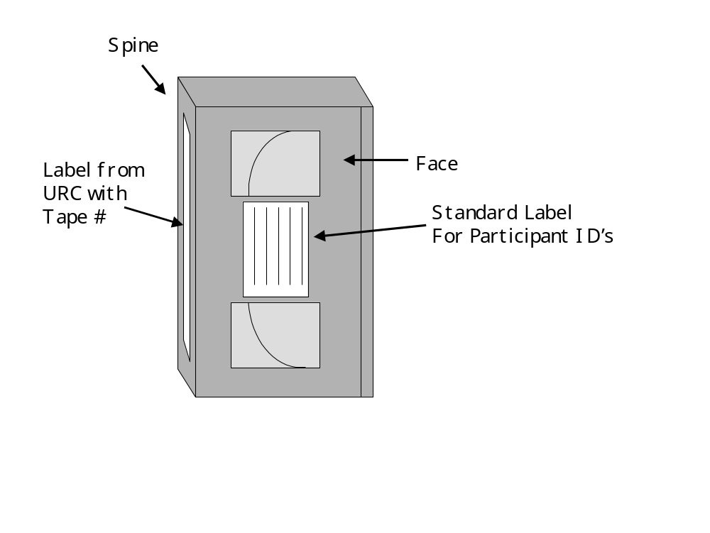

Appendix 4 Weekly Shipping Log

JHS SHIPPING LOG

1. BATCH NUMBER: (Beginning with 01)

2. SHIPPING TO: ULTRASOUND READING CENTER
WFUSM PUBLIC HEALTH SCIENCES
4310 ENTERPRISE DRIVE, SUITE C
WINSTON-SALEM, NC 27106

3. REPORTING PERIOD: STARTING DATE: __/__/__ (mm/dd/yy)

ENDING DATE: __/__/__ (mm/dd/yy)

4. ITEMS:

TYPE OF ITEM NUMBER SENT NUMBER RECEIVED

A. SVHS TAPES *

B. PHANTOM SCAN TAPE *

C. PAPER FORMS:

TAPE LOG SHEET *

SCAN REVIEW FORM *

OTHER: *

- COMMENTS CONCERNING SHIPMENT CONTENTS:

6. DATE SENT: / /

7. INITIALS OF STAFF MEMBER PREPARING SHIPMENT:

- *COMMENTS ON CONDITION OF TOTAL SHIPMENT ON ARRIVAL:

9. *ARRIVAL DATE: / /

10. *INITIALS OF STAFF MEMBER RECEIVING SHIPMENT:

*URC RECORDS HERE

Appendix 5 URC Contact Information

The JHS URC is located in Winston-Salem, North Carolina and is part of Wake
Forest University School of Medicine. Contact information for the URC is given below.

Greg Evans, Director
Department of Public Health Sciences
Wake Forest University School of Medicine
Winston-Salem, NC 27157
Phone: 336-716-6016
Fax: 336-716-6427
Email: gevans@wfubmc.edu

Delilah Cook, Ultrasound Coordinator
Ultrasound Reading Center
4310 Enterprise Drive, Suite C
Winston-Salem, NC 27106
Phone: 336-759-2137
Fax: 336-759-2139
Email: drcook@wfubmc.edu

Teresa Crotts, Sonographer Reviewer/Trainer
Department of Neurology
Wake Forest University School of Medicine
Winston-Salem NC 27157
Phone: 336-716-6016
Email: tcrotts@wfubmc.edu

Carolyn Bell, Librarian
Ultrasound Reading Center
4310 Enterprise Drive, Suite C
Winston-Salem, NC 27106
Phone: 336-759-2137
Fax: 336-759-2139

In general, questions related to equipment, sonographer performance or protocol interpretation should be directed to Teresa Crotts; questions related to carotid ultrasound data values, reader alerts or technician certification should be directed to Delilah Cook; and questions related to tracking shipments, cassette tapes or participant scans should be directed to Carolyn Bell.

Appendix 6 Reading List

"The Language of Anatomy"
From: Gardner, W.D. & Osburn, W. A. (l973) Structure of the Human Body. (2nd ed.) Philadelphia: W.B. Saunders Company.

"Angiology"
From: Williams, P.L. and Warwick, R., eds. (l980) Gray's Anatomy. (36th ed.) Philadelphia: W.B. Saunders Co.

"Blood Supply to the Head and Neck"
From: Fried, L.A. (l976) Anatomy of the Head, Neck, Face, and Jaws. Philadelphia: Lea & Febiger.

"Systemic and Pulmonary Circulations"
From: Underhill, S.L., Woods, S.L., Sivarajan, E.S. and Halpenny. C.J., eds. (l982) Cardiac Nursing. Philadelphia: J.B. Lippincott Co.

"Pathogenesis of Atherosclerosis"
From: Cardiac Nursing.

"The Carotid Plaque"
From: Robicsek, F. Ed. (l986) Extracranial Cerebrovascular Disease Diagnosis and Management. NY: McMillan Publishing.

Diagnostic Ultrasound, Principles, Instruments, and Exercises by Frederick W. Kremkau, Ph.D. Third Edition Publisher: W. B. Saunders Company Harcourt Brace Jovanovich, Inc.

Chapter 1 from Diagnostic Ultrasound;
Frederick W. Kremkau, Ph.D. 3rd edition.

Chapter 2, pages 9-30 in Diagnostic Ultrasound.

Chapter 2, pages 41-45 of Diagnostic Ultrasound.

Chapter 3 of Diagnostic Ultrasound.

Chapter 4 pages l05-ll4 and pages 130-137 of
Diagnostic Ultrasound.

"How a B-Mode Image is formed - A Summary".

Chapter 5 in Diagnostic Ultrasound.

Article, "Artifacts in Ultrasound Imaging" (Kremkau & Taylor)

Chapter 6 in Diagnostic Ultrasound. Skip Section 6.3.

Chapter 7 in Diagnostic Ultrasound. Skip Section 7.3.

Pignoli, P., Termoli, E., Poli, A., Oreste, P., Paoletti, R. (l986) "Intimal Plus Medial Thickness of the Arterial Wall: A Direct Measurement with Ultrasound Imaging." Circulation. 74 (6), 1399-1406.

Fact Sheet on Heart Attack, Stroke, and Risk Factors.
(l987) American Heart Association. Dallas, TX.

Pages 132-143 "Coronary Artery Disease Risk Factors"
From: Cardiac Nursing

Coronary Risk Factor Statement to the American Public.
(l987) American Heart Association. Dallas, TX.

Grundy, S.M. (l986) Cholesterol and coronary heart disease. JAMA. 256 (20) 2849-2858.

Eron, Carol (l988) Young hearts. Science News. 134, 234-236.

Stamler, J., Wentworth, D. & Neaton, J.D. (l986) "Is the Relationship Netween Serum Cholesterol and Risk of Premature Death From Coronary Heart Disease Continuous and Graded?" JAMA. 256 (20) 2823-2828.

Enos, W.F., Holmes, R.H. & Beyer, J. (l953) "Coronary Heart Disease Among United States Soldiers Killed in Action in Korea: A Preliminary Report." JAMA. 152, 1090-1093. (Reprinted l986 JAMA 256 (20).

Appendix 7 Articles of Interest

"High Resolution B-Mode Ultrasound Scanning Methods in the Atherosclerosis Risk in Communities Study (JHS)", M.G. Bond et al. Journal of Neuroimaging, Vol l, No 2, May 1991, pages 68-73.

"High Resolution B-Mode Ultrasound Reading Methods in the Atherosclerosis Risk in Communities (JHS) Cohort, Ward A. Riley, et al. Journal of Neuroimaging, Vol l, No 4, November 1991, pages 168-172.

"An Approach to the Noninvasive Periodic Assessment of Arterial Elasticity in the Young" Riley, Barnes and Schey. Preventive Medicine 13, 169-184 (l984).

"Ultrasonic Measurement of the Elastic Modulus of the Common Carotid Artery: The Atherosclerosis Risk in Communities (JHS) Study". Accepted by Stroke, l992.

